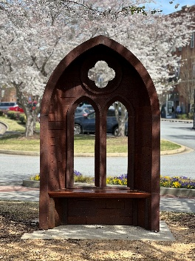
2026 Suwanee Half/10k/5k Sponsor Tiers

Presenting Sponsor: $1000.00
- 6 free runners
- Allowed to set up canopy/tent and advertise at race
- Largest Logo on T-Shirt, social media mention and registration site
- Signage at start/finish
- DJ mentions at race

Platinum Sponsor: $750.00
- 5 free runners
- Allowed to set up canopy/tent and advertise at race
- Larger Logo on T-Shirt, social media mention and registration site
- DJ mentions at race

Gold Sponsor: $500.00
- 4 free runners
- Allowed to set up canopy/tent and advertise at race
- Larger Logo on T-Shirt, social media mention and registration site
- DJ mentions at race

Silver Sponsor: $250.00
- 2 free runners
- Allowed to set up canopy/tent and advertise at race
- Logo on T-Shirt, social media mention and registration site
- DJ mentions at race

Bronze Sponsor: $125.00
- 1 free runner
- Allowed to set up canopy/tent and advertise at race
- Logo on T-Shirt, social media mention and registration site

Vendor: $50.00
- Allowed to come and set up and sell/advertise products

